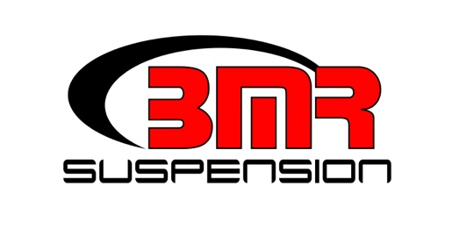

FOR IMMEDIATE RELEASE

BMR Solid Motor Mount Kit for 1978-1987 G-Body
MM461 - $129.95

Reduce engine movement and improve throttle response on your 1978-1987 G-Body with Solid Motor Mounts from BMR Suspension. The factory mounts are designed to absorb noise and vibration for a smooth ride, but do little for performance. Formed from 3/16-inch laser cut steel plate, our G-Body motor mounts offer uncompromised strength and stiffness. The BMR Solid Motor Mounts (MM61) eliminate engine movement by removing the soft rubber bushings that contribute to deflection. The MM461 Solid Motor Mounts allow for the instant acceleration, quicker than a polyurethane bushing or rubber bushing due to zero flex or deflection. Our G-Body Poly Motor Mounts are a direct factory replacement and include both upper and lower mounts to maintain factory engine height. BMR has designed the M461 for street performance, autocross, and drag racing applications. Installation time is 2-3 hour. Available in black hammertone or red powdercoat for long-lasting good looks. Proudly made in the U.S.A.

To preview all of BMR’s high-performance suspension parts, please visit www.bmrsuspension.com, email sales@bmrsuspension.com, or contact them at BMR Suspension, 928 Sligh Ave, Seffner, FL 33584, 813-986-9302, Fax: 813-986-8055.

Editors: Download this press release and high resolution images at: www.bmrsuspension.com/?page=pressrelease

